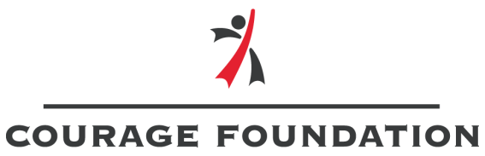

CHILD AND WOMAN PROTECTION POLICY
This document outlines the minimum common standards for child and woman protection that Courage Foundation has put in place with appropriate procedures and mechanisms in its operations.
The main objective of child and woman protection policy is to protect children and women from abuse. Children and women need support and security, protection from the effects of poverty, harm, isolation and violence.
DEFINITIONS OF CHILD AND WOMAN PROTECTION POLICY IN THE FOUNDATION
In the sense of an additional provision to the Regulations on the Implementation of the CPA in Bulgarian Legislation / paragraph 1 /:
"Violence" against a child and woman is any act of physical, mental or sexual abuse, neglect, commercial or other exploitation that results in actual or probable harm to the health, life, development or dignity of the individual, which may occur in family, school and social environment.
"Physical violence" means personal injury, including pain or suffering without a health disorder.
"Mental abuse" means all actions that can have a detrimental effect on the mental health and development of the individual, such as underestimation, mockery etc.
VISION
Courage Foundation works for a society where each child and woman has his or her own family and enjoys the best opportunities for life and development. The Foundation has an impact on child and woman development in Plovdiv and the region and supports activities locally.
MISSION
The Courage Foundation advocates for the rights and well-being of children and women by operating at regional, national and international levels. Works for a society where citizens are empowered to participate actively, directly and responsibly in decision-making and policymaking at local, regional, national and European level.
PRIORITIES
1. Putting the child and woman at the center of life and activities
2. Children’s, youth and women participation
3. Development of the Foundation

GOALS
1. Introducing and implementing mechanisms for civic participation and influencing local policies - Promoting the spiritual, intellectual and professional growth of children and women through education, sport and arts.
2. Collaboration with state and other non-governmental organizations to solve problems.
3. Carrying out charity events in order to raise funds for the achievement of the Foundation's goals.
4. Developing policies for children and women.
5. Changing society's attitudes towards the rights of the child and woman.
6. Building a model for participation.
7. Sustainability and development of the Foundation.
8. Capacity building.

STANDARDS FOR CHILD AND WOMAN PROTECTION
The basic principles that meet the standards are directly linked to the rights of the child and woman and comply with Bulgarian and international legislation. They reflect the minimum requirements and mechanisms to be met by the Foundation to ensure effective protection of the child and woman against abuse.
Standard 1
Written document on a policy to ensure the safety of children and women:
1.1. Written in clear and accessible language and reflecting the Foundation's understanding abuse and violence;
1.2. There are clear rules outlining the steps to be taken in the presence of a child’s and woman safety concerns.
1.3. All employees are familiar with the protection rules and are available to everyone.
Standard 2
Implementation of the Child and Woman Protection Policy: prevent threat, discrimination, rejection or other negative attitudes, as well as the inability of the parent, guardian and guardian or care provider (in case of child) to provide an appropriate supportive environment
Standard 3.
Prevention of violence against children and women:
3.1. In the selection of staff, volunteers and consultants to implement projects and other activities, a methodology and assessment of their suitability for work with children and women shall be applied.
3.2. Each new member and new employee in connection with the execution of a project activity shall provide up-to-date documents required by law and / or duly required by the employer, incl. and recommendations.
3.4. The Foundation's projects and programs promote mechanisms for the monitoring and protection of children and requirements for compliance with the Child and Women Protection Policy.
Standard 4
Training to ensure the safety of children and women:
4.1. All members, staff, volunteers, consultants and other assistants are instructed in child and women protection upon their involvement in the Foundation's activities.
4.2. Persons responsible for the selection of employees to carry out activities under the projects, receive guidance on safe selection methods
Standard 5
Guarantee of equal protection for all, regardless of gender, age, ethnicity and religion:
5.1. Child and women protection training and procedures help employees identify the risks that some children and women are exposed to because of their ethnicity and / or race, age, gender, religion, culture, disability.
5.2. At the Foundation, everyone is responsible for mutual respect, tolerance and non-discrimination.
Standard 6
Implementation and monitoring:
6.1. There are written documents that show what the procedures and mechanisms are in place when implementing a child and woman protection policy.
6.2. All reports and cases of abuse are documented and monitored.
Standard 7
Working with partners to meet standards
7.1. There is a process of communication with partners on child protection issues, information and experience are exchanged, and coherent approaches to child and women protection are being developed.
7.2. The partners are aware of the existing Child and women Protection Policy and its accompanying procedures.
IMPLEMENTATION PROCEDURES AND MECHANISMS
1. The Chairperson of the Foundation shall be responsible for the implementation of this policy.
2. In case of fear and / or identified violence against a child and woman
- communication passes directly through the responsible person to the Foundation, designated by the Chairperson.
- Any information relating to abuse must be documented.
3. Policy clarifications and procedures are part of the introductory process for new members, staff, volunteers or associates.
4. The organization of activities involving children, including the transportation of children or women, follow the requirements of the Bulgarian legislation.
5. The policy is monitored and evaluated to verify its security and proper implementation.
USE OF IMAGES AND VIDEO MATERIALS
When using visual aids, the guiding principle of Courage Foundation is to respect the dignity of portraying children, women, families and communities. The Foundation's image policy is part of the Child and Women Protection Policy.
1. Images of children are only used when there is a permission (signed declaration) from a parent / legal guardian.
2. Authorization is required for the taking of photographs or video material on a case-by-case basis and clearly stated in the declaration of authorization for what purposes the images will be used.
Consent for the taking and use of photographs is sought from parents of children and those with parental responsibility, or directly from children / young people when they are of the appropriate age. (applies to children over the age of 14, according to Art. 11, Para. 3 of the CPA).

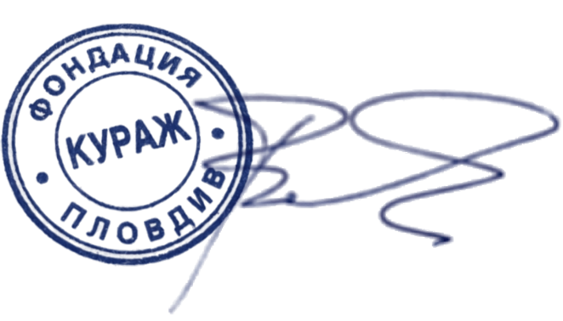
Courage Foundation
President
Lucia Veleva

